The Queensland Family and Child Commission (QFCC) is implementing Queensland’s new Child Safe Organisations legislation. This is the biggest improvement to child safeguarding in Queensland’s history and will help our state build a culture of safety and wellbeing for all children.

More than 40,000 organisations across Queensland that work with children or provide services to them will need to implement Child Safe Standards and the Universal Principle to be considered child safe and comply with the legislation.

To help organisations build their capability and capacity to be child safe, we have launched our Child Safeguarding Grants Program, which offers eligible organisations grants of up to $90,000 in one of three categories:

1. Enhancement funding for organisations to extend the reach and impact of existing child safeguarding training, programs and services.
2. Sector specific capability and capacity building packages.
3. Readiness and awareness packages for Aboriginal and Torres Strait Islander organisations.

For more information about eligibility criteria, closing dates, and instructions on how to apply, visit the QFCC website: [www.qfcc.qld.gov.au/childsafe/grants](http://www.qfcc.qld.gov.au/childsafe/grants)

We welcome your support in promoting the program among your networks so that we reach as many Queensland organisations as possible. You can find shareable resources for your communications channels below.

# Shareable resources

## Copy

The Queensland Family and Child Commission (QFCC) has opened its Child Safeguarding Grants Program!

If you are one of the more than 40,000 organisations in Queensland that works with children, provides services to them or facilities for their use, you will soon need to meet new requirements under the *Child Safe Organisations Act 2024* to be considered child safe. These include implementing Child Safe Standards and the Universal Principle to protect the safety and wellbeing of all children.

The QFCC is offering grants of up to $90,000 to help organisations build their capability and capacity to become child safe.

Applications are now open. To view the grant categories, eligibility criteria, closing dates, terms and conditions, and to apply, visit: [www.qfcc.qld.gov.au/childsafe/grants](http://www.qfcc.qld.gov.au/childsafe/grants)

## QFCC channels:

**LinkedIn:** QFCC – @Queensland Family and Child Commission (QFCC)

**Facebook:** @keepkidssafeqld

**Instagram:** @keepkidssafeqld

## Social media tiles

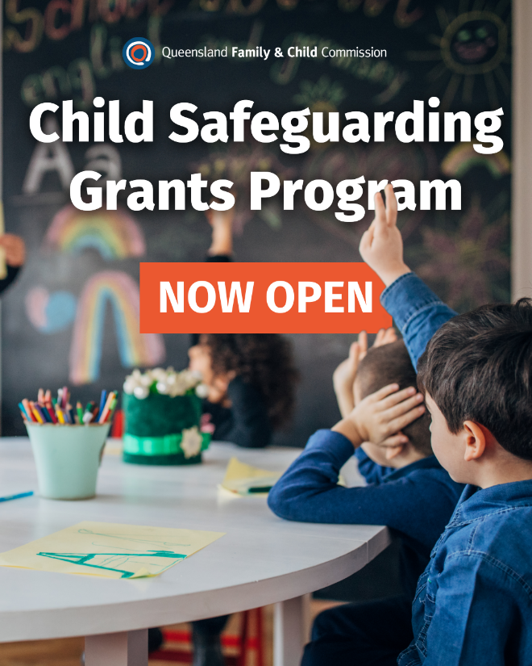

# Media and Communication contact:

**Kirstine O’Donnell** | Manager, Media and Communication

**Phone:** 0404 971 164

**Email:** [media@qfcc.qld.gov.au](mailto:media@qfcc.qld.gov.au)