# Shareable digital resources

The Queensland Family and Child Commission (QFCC) has launched the Data Explorer, an online, interactive resource that reports on the wellbeing of Queensland children, their families and communities.

We welcome your support in promoting the Data Explorer across your networks. Shareable social media and communication resources, including a short promo video, are included below for your use.

## Promotional video

A short video about the Data Explorer can be found here: <https://www.youtube.com/watch?v=Ii619KISmZo>

You are welcome to share this video on your channels.

## Social media copy and tile

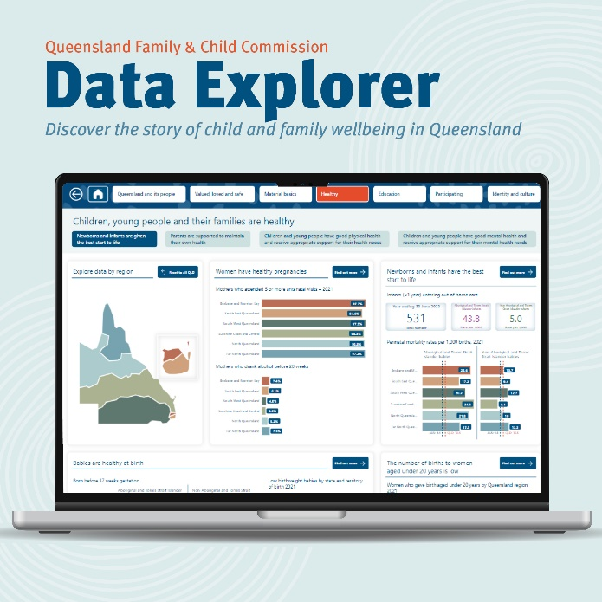The Queensland Family and Child Commission has launched the Data Explorer, a go-to resource that reports on the wellbeing of Queensland’s 1.6 million children, their families and communities.

Comprising thousands of data points and more than 20 case studies that showcase people and programs that are making a difference, the Data Explorer presents a holistic picture of child, family and community wellbeing in Queensland. It maps to the wellbeing framework developed by the Australian Research Alliance for Children and Youth (ARACY), which sets out the six interconnected factors children and families need to thrive.

You can explore the data and stories now at [www.qfcc.qld.gov.au/dataexplorer](http://www.qfcc.qld.gov.au/dataexplorer)

## Newsletter article

The Queensland Family and Child Commission (QFCC) has launched the Data Explorer, a go-to resource that reports on the wellbeing of Queensland’s 1.6 million children, their families and communities.

Comprising thousands of data points and more than 20 case studies that showcase people and programs that are making a difference, the Data Explorer presents a holistic picture of child, family and community wellbeing in Queensland, describing their health, education, wealth, living, family circumstances, and so much more.

The data and case studies map to the wellbeing framework developed by the Australian Research Alliance for Children and Youth (ARACY), which sets out the six interconnected factors children and families need to thrive: feeling valued, loved and safe; having material basics; being healthy; being engaged in education; participating in their communities; and having a positive sense of identity and culture.

The Data Explorer is an essential resource for everyone interested in children and families in Queensland—researchers, policy-makers, sector organisations, students, media—and it’s available now to explore on the QFCC website: [www.qfcc.qld.gov.au/dataexplorer](http://www.qfcc.qld.gov.au/dataexplorer)

